**Experiment No 8 & 9:**

**Practice Queries using Aggregate functions, Group By, Having Clause and Order by Clause.**

**Query:**

create database db;

use db;

create table employee

(emp_id int,

emp_name varchar(255),

sub varchar(255));

alter table employee

add primary key(emp_id);

desc employee;

select * from employee;

insert into employee values(100,'chandrashekar','DBMS');

insert into employee values(101,'Nagamani','OS');

insert into employee values(102,'Rojarani','BEFA');

insert into employee values(103,'BapiRaju','JAVA');

insert into employee values(104,'Nagaveni','DM');

truncate table employee;

select * from employee;

drop table employee;

create table students

(roll_no int primary key,

first_name varchar(100),

last_name varchar(100),

DOB date,

phone_no int);

drop table students;

create table students

(roll_no int primary key,

first_name varchar(100),

last_name varchar(100),

DOB date,

phone_no int8,

unique (phone_no));

desc students;

insert into students values(591,'Nitisha','Reddy','2001-10-23',7894321675);

insert into students values(592,'Balki','Rachana','2001-09-25',9390226605);

insert into students values(593,'Dharmana','Mounika','2001-09-16',8765098857);

insert into students values(594,'Keerthi','Renuka','2001-06-07',8765099006);

insert into students values(595,'Priyanka','Challa','2001-04-03',8765099005);

select * from students;

drop table academic_details;

create table academic_details

(roll_no int not null,

dept char(3),

attendance float,

email varchar(30),

foreign key (roll_no) references students(roll_no));

desc academic_details;

select * from academic_details;

insert into academic_details values(591,'CSE',95.8,'nitishareddy@gmail.com',2023);

insert into academic_details values(592,'CSE',98.9,'balkirachana@gmail.com',2023);

insert into academic_details values(593,'CSE',92.0,'dharmanamounika@gmail.com',2023);

insert into academic_details values(594,'CSE',74,'keerthi@gmail.com',2023);

insert into academic_details values(595,'CSE',72,'priyanka@gmail.com',2023);

alter table academic_details

add pass_out year;

create table marks

(roll_no int not null,

Dbms int,

OS int,

Befa int,

DM int,

java int,

foreign key (roll_no) references students(roll_no));

desc marks;

insert into marks values(591,23,22,21,20,22);

insert into marks values(592,24,25,23,22,24);

insert into marks values(593,21,22,20,20,22);

insert into marks values(594,20,22,21,20,22);

insert into marks values(595,21,20,19,20,20);

select * from academic_details;

select attendance from academic_details;

select * from marks;

select * from academic_details where pass_out = 2023;

#count

select count(attendance) from academic_details

where attendance > 75;

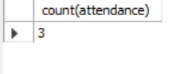

#Average

select Avg(OS) from marks;

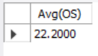

#min

select roll_no,min(Dbms) from marks;

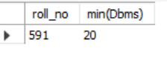

#max

select max(OS) as highestmarks from marks;

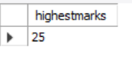

#sum

select sum(Befa) from marks;

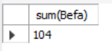

#group by

select count(roll_no), OS

from marks group by OS;

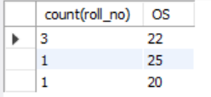

#having

select count(roll_no), OS

from marks group by OS

having count(roll_no) > 2;



#order by

select roll_no,attendance from academic_details

order by attendance desc;

